HILLY FIELDS FOOTBALL CLUB
SEASON 15: 1981-82
FIRST TEAM:
BECKENHAM LEAGUE:
P W D L F A Pts Pos
Division 1 18 12 2 4 59 24 26 2nd
Beckenham League Cup 4 3 0 1 13 3
Beckenham Hospital Cup 1 0 0 1 0 1
Friendly 7 6 0 1 25 11
TOTAL 30 21 2 7 96 39

Apps Gls Apps Gls
Mark Aspill 28 23 Steve Jordan 30 9
Phil Aspill 1 0 Gary Lattimore 2 0
Steve Banks 1 0 Terry Mills 23 3
Steve Brine 21 6 Luis Navarro 1 0
Doug Bryant 25 2 Tony Osborne 1 0
Colin Chandler 4 0 Gary Reid 5 0
Ian Chapman 22 0 Delroy Richards 17 0
Mark Cooper 25 1 Graham Smith 1 0
Gary Crane 29 4 Alan Speaight 25 22
Don Field 26 5 Colin Walker 30 7
Barry Herbert 4 0 Gary West 1 0
Eddie Hicken 2 0 Rob Williams 2 0
Malcolm Hill 25 13 Nick Woolhouse 1 0
Charlie Jordan 1 1

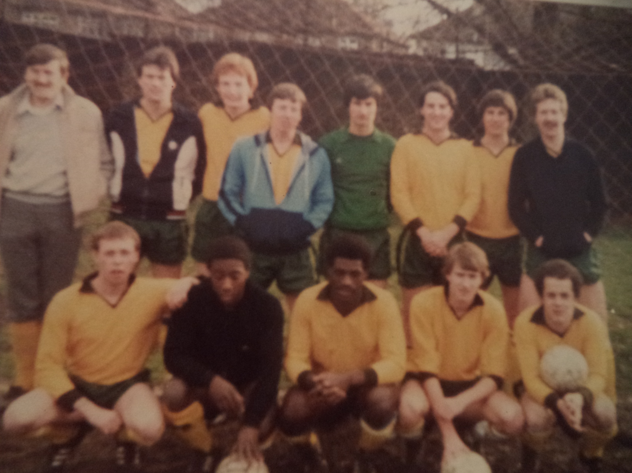
L-R Back: Charlie Jordan, Terry Mills, Ian Chapman, Malcolm Hill, Doug Bryant, Alan Speaight, Steve Brine, Mark Cooper L-R Front: Colin Walker, Delroy Richards, Don Field, Steve Jordan, Gary Crane

